FOR IMMEDIATE RELEASE Media Contacts
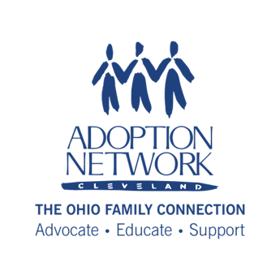
Tammy Gibson Willet
Director of Development & Communications
C: (440) 319-7040

tammy.willet@AdoptionNetwork.org

Betsie Norris
Executive Director
O: (216) 482-2314 or C: (216) 299-1323
betsie.norris@adoptionnetwork.org

Emergency Fund Helps Adoptive, Kinship, and Foster Families Maintain Stability Despite Challenging Times

Cleveland, OH - Adoption Network Cleveland is continuing its commitment to supporting families to maintain stability for adoptive, kinship and foster children through a new partnership with the Governor’s Office of Faith-based and Community Initiatives. Through a grant of Federal TANF (Temporary Assistance to Needy Families) funds, Adoption Network Cleveland has established the Family Resilience Fund, which will support adoptive, kinship, and foster families, as well as adults who were formally in foster care themselves and are now parents, with short-term, emergency assistance. Kinship families can be connected through the child welfare system or less formally. The Fund will provide cash assistance for rent, utilities, clothing, and child-care assistance for eligible families. Eligibility guidelines for Federal funding does include a maximum household income of 200% of Federal Poverty guidelines, including liquid assets.

“Stability for a child who has been through trauma that led to them being adopted, in foster care, or in the care of a nonparent relative is of critical importance. All families can encounter times of crisis. Being able to help families bridge a short-term gap in the face of an unprecedented challenge can make all the difference. Adoption Network Cleveland is happy we can provide needed extra support and assistance during this challenging time,” says Betsie Norris, Executive Director.

Families across Cuyahoga County and surrounding counties have been hit hard by the impacts of COVID-19 including unexpected unemployment, reductions in household incomes and other emergencies, and it is important that we ensure that adoptive, kinship, and foster families are able to bridge short-term difficulties and continue to provide a stable, loving home for their children. For young adults who were themselves in foster care, we know that the bridge to self-sufficiency often does not have a safety net and can be even more tenuous when they are caring for children of their own. Families who are experiencing financial difficulties and feel they may qualify are encouraged to find out more about the Family Resilience Fund through our website at https://bit.ly/ANCresilience or by calling our office at (216) 482-2324.
###
About Adoption Network Cleveland
Adoption Network Cleveland: The Ohio Family Connection is an innovative non-profit organization with over 30 years of experience serving the adoption and foster care communities. Our organization fulfills otherwise unmet needs for information, advocacy, education and support for adult adoptees, birthparents and birth family; adoptive, kinship and foster families; youth in foster care and foster alumni; and related professionals. More recently, the organization has expanded its services to use its expertise in adoption search, reunion with birth family, and peer support networks to assist those who have been donor-conceived or have misattributed parentage. Adoption Network Cleveland is a member of Greater Cleveland Community Shares. The organization can be found online at www.adoptionnetwork.org or on social media at @AdoptionNetCle.

